Question 29:
Write an HTML program to add a background-image property using URL and style tag using
internal type of CSS.

Program:
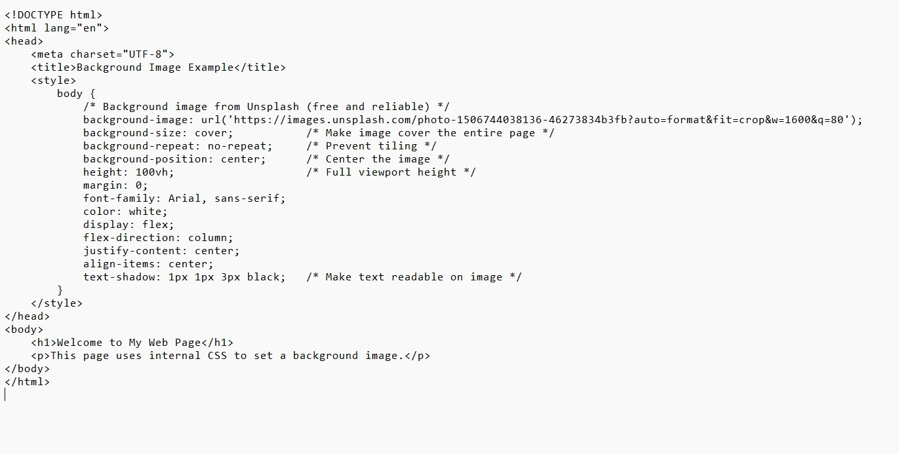

Output:


